**HEART STROKE PREDICTION SYSTEM USING IOT AND MACHINE LEARNING**

Sai Shriya1*, Krishna Sri1, Dr. K Raghu2, Smruthi Sreshta1, Sirisha1

1 Student, Department of CSE, Geethanjali College of Engineering & Technology, Hyderabad, TS, India.

2 Associate Professor of CSE, GCET, Hyderabad, TS, India.

**Corresponding Author Email:** raghukuphd@gmail.com

**ABSTRACT:**

The IoT-based wearable devices are integrated with machine learning (ML) to enhance the prediction and prevention of heart strokes. The system uses smart-watches with sensors to continuously monitor physiological parameters, such as heart rate, blood pressure, and electrocardiogram (ECG) signals. Real-time data from these sensors is transmitted to a mobile application, where a Convolutional Neural Network (CNN) processes the information to detect patterns and baseline metrics. The app compares incoming data with these learned patterns to identify anomalies, such as irregular heart rhythms or significant blood pressure fluctuations, which could signal an increased risk of stroke or heart attack.

Preliminary tests have shown that LSTM modelhas achieved accuracy rates between 85% and 96%, with the potential to exceed 98% with optimized data preprocessing and algorithm fine-tuning. Future improvements include incorporating advanced hybrid models for more accurate predictions, expanding health data inputs to include lifestyle factors, and offering personalized health recommendations based on user history.

**Keywords:** ECG, Sensors, CNN, RNN, Accuracy.

**INTRODUCTION**

Stroke remains one of the leading causes of death and long-term disability worldwide, underscoring the urgent need for effective and timely detection methods to enhance patient outcomes. A stroke, characterized by the abrupt interruption of blood flow to the brain, can result in significant neurological impairment or death if not promptly managed [6-7]. Traditional methods for stroke detection often rely on clinical evaluations and imaging techniques, which may not always provide immediate insights or be readily accessible in emergency situations [8]. Moreover, these methods may not always detect subtle physiological changes that precede a stroke [9].

Recent advancements in technology, particularly in machine learning (ML) and the Internet of Things (IoT), offer innovative solutions for improving stroke detection and prevention. ML algorithms have demonstrated significant potential in analysing complex physiological data, enabling the identification of subtle patterns and anomalies that may indicate a stroke [4].

These algorithms can process vast amounts of data from various sources to provide predictive insights, thereby enhancing early detection and intervention strategies. In parallel, IoT technology has revolutionized healthcare by enabling continuous and remote monitoring of vital signs through wearable devices [1-3]. These devices facilitate real-time data collection and transmission, allowing for ongoing observation of physiological parameters such as heart rate, blood pressure, and electrocardiogram (ECG) readings [5]. This constant stream of data can be critical for identifying potential stroke indicators and providing timely alerts to both users and healthcare providers.

**RELATED WORK:**

|  |  |  |  |  |
| --- | --- | --- | --- | --- |
| **Year** | **Author(s)** | **Title of the Paper** | **Methodologies Used** | **Limitations** |
| |  | | --- | | 2020 |  |  | | --- | |  |  |  | | --- | |  |  |  | | --- | |  |  |  | | --- | |  | | Choi, et.al | ECG-Based Detection of Stroke and Heart Disease Using Machine Learning Techniques | Supervised ML algorithms to classify ECG data for stroke detection | Limited dataset size, overfitting due to small training sets, and poor generalization across diverse patient groups |
| |  | | --- | | 2021 |  |  | | --- | |  |  |  | | --- | |  |  |  | | --- | |  |  |  | | --- | |  | | Rahman, et.al | Machine Learning Algorithms for Stroke Prediction:A Review | Review of ML algorithms (SVM, Decision Trees, Neural Networks) for stroke prediction | Lack of real-time data and difficulty in choosing the best algorithm for varying datasets |
| |  | | --- | | 2021 |  |  | | --- | |  |  |  | | --- | |  |  |  | | --- | |  | | Sá, J. P. R. C et.al | Wearable and Implantable Sensors for Healthcare: A Review of Technology, Applications, and Future Directions | Sensor fusion and IoT-based real-time data collection | High energy consumption of sensors and data privacy concerns due to constant data streaming |
| |  | | --- | | 2022 |  |  | | --- | |  |  |  | | --- | |  | | Zhang et.al | Advances in Wearable Health Monitoring Systems for Stroke Prevention | Real-time monitoring with sensor data, integrated with IoT for alert systems | High device cost and limited accessibility for low-income patients, coupled with network dependency |
| |  | | --- | | 2021 |  |  | | --- | |  |  |  | | --- | |  | | Sharma et.al | Real-Time Monitoring of Cardiovascular Events Using IoT-Based Wearable Devices | Continuous real-time data collection with predictive analytics using IoT | Inconsistent sensor accuracy and high susceptibility to external environmental noise |
| |  | | --- | | 2020 |  |  | | --- | |  | | |  | | --- | | Gupta et.al |  |  | | --- | |  | | Machine Learning Approaches for Stroke Risk Assessment Using Wearable Devices | ML models (e.g., Random Forest, SVM) trained on patient sensor data | Limited training data results in reduced accuracy, and lack of |
| 2023 | Priyanka et al. | Heart Stroke Risk Prediction Using Machine Learning and Deep Learning Algorithm | Hybrid approach combining ML and DL algorithms to predict heart stroke risk from real-time IoT sensor data | Limited scalability and user-friendliness of the model for non-technical users |

**PROPOSED SYSTEM:**

The proposed model leverages the Internet of Things (IoT) technology and machine learning to monitor users' health in real-time and predict the risk of a heart stroke. Using wearable sensors like smartwatches, the system continuously collects vital health data, processes it, and analyses patterns indicative of cardiovascular risks. This end-to-end system is structured into distinct stages, as illustrated in the architecture diagrams Fig.1 and Fig.2. The following sections describe the model's workflow in detail:

**1. Data Collection from Wearable Devices**

* 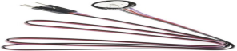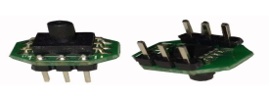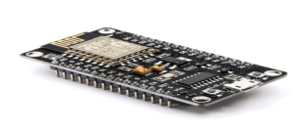**Start:** The process begins with the smartwatch collecting vital health parameters from various biosensors. These include heart rate, blood pressure, SpO2 levels, ECG signals, Node MCU and physical activity data. The sensors integrated into the smartwatch work together to provide a comprehensive set of physiological signals:

**Figure 1a: Node MCU Figure 1b: Blood pressure sensor Figure 1c: Pulse sensor**

These sensors provide a steady stream of real-time health data, which is then transmitted to a central processing system using protocols like Bluetooth or Wi-Fi for secure data transfer. This information is stored on a cloud-based infrastructure, ensuring large-scale data management.

**2. Data Preprocessing and Feature Extraction**

**Pre-process the Data:** Once the smartwatch transmits the data to the cloud-based server as shown in Figure 2, the system initiates the preprocessing phase. Raw sensor data often contains noise and inconsistencies due to factors like user movement or environmental interference. Pre-processing involves Noise Removal, Missing data, Normalization. Then, Feature extraction is performed on the cleaned data to identify key health parameters indicative of heart stroke risk, such as heart rate variability or ECG waveform irregularities.

**Figure 2: Flowchart of the data received by the sensors to the app**

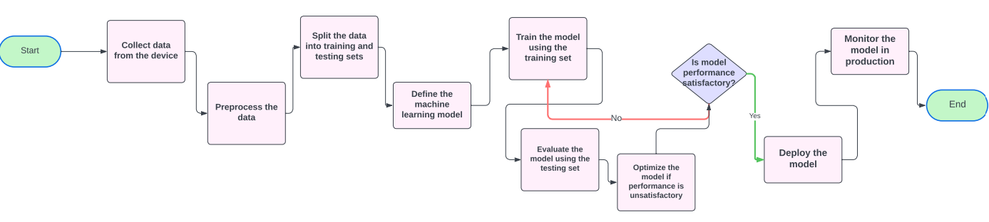

**Figure 3: Flowchart for the model**

**3. Splitting Data and Machine Learning Model Definition**

* As shown in Figure 3, After pre-processing, the data is divided into two subsets: a training set and a testing set. This division allows the machine learning model to learn from historical data and evaluate its performance on new data. After that, the model is chosen based on the nature and complexity of the health data. Various machine learning algorithms are considered like CNN, RNN and SVM.

**4. Training and Evaluation of the Model**

* During this phase, the model learns to identify patterns associated with heart stroke risks by analysing the training dataset and then the model’s performance is assessed using the testing set, an unseen dataset. Metrics like accuracy, precision, recall, F1-score, and the ROC-AUC curve are used to measure how well the model distinguishes between normal and abnormal heart conditions.

**5. Model Optimization**

* **Is Model Performance Satisfactory?** If the model's performance does not meet the desired threshold, it undergoes optimization. This involves Hyper parameter Tuning like learning rate, batch size, Feature engineering and Model Selection.

**6. Model Deployment for Real-Time Monitoring**

* 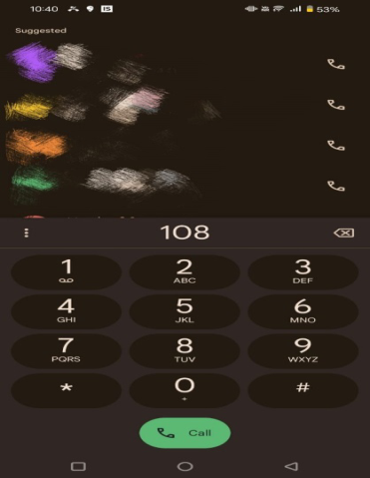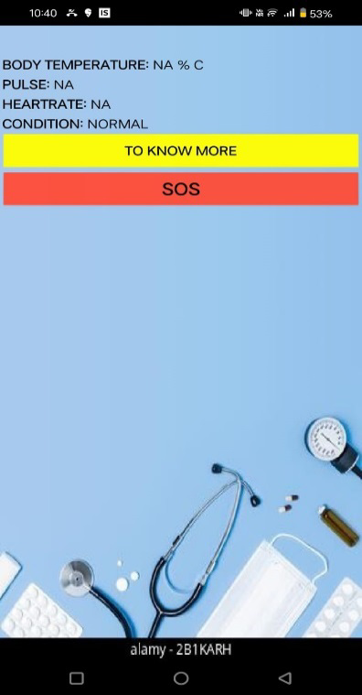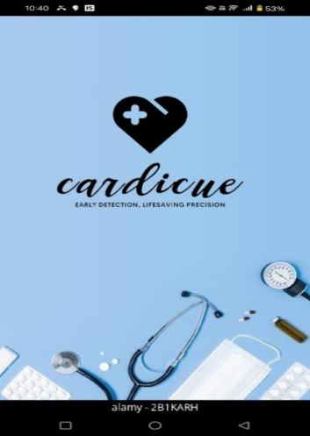**Deploy the Model:** Once optimized and trained, the model is deployed for real-time monitoring as shown in Fig. 4. It continuously processes incoming data streams from users’ smart watches, analysing health metrics for potential anomalies.

 **Figure 4a: first page Figure 4b: main page Figure 4c: SOS button**

**7. Real-Time Alerts and User Feedback:** Thisalert includes actionable insights, such as recommending a medical consultation or lifestyle changes. The app also provides real-time health trends and periodic risk assessments, enabling users to take preventive measures before a critical event occurs.

**Results:**

Table 1: Accuracy with different models

|  |  |  |
| --- | --- | --- |
| S. No. | Models | Accuracy |
| 1 | CNN | 97.46% |
| 2 | RNN | 96.34% |
| 3 | LSTM | 98.27% |

Table 1 describes the accuracy of different models used for stroke detection, with CNN achieving 97%, RNN at 96%, and LSTM performing the best at 98%. CNN excels in feature extraction from signals, while RNN handles time-series data, and LSTM's ability to capture long-term dependencies leads to the highest accuracy.Our approach not only increases accuracy but also enhances the model's adaptability across diverse patient populations.

**Conclusion**

This approach seamlessly integrates IoT-enabled smartwatches with machine learning to provide an innovative solution for heart stroke prediction. Machine learning algorithms analyse this data, identifying patterns and anomalies that may indicate an impending heart stroke. The system then alerts users and healthcare providers, allowing for timely interventions that can prevent critical events. This technology-driven approach not only enhances the early detection of stroke risks but also reduces the burden on healthcare systems through personalized monitoring. Ultimately, the combination of wearable devices and machine learning promises to improve patient outcomes by enabling more efficient, preventive healthcare solutions.

**REFERENCES**

1. Sá, J. P. R. C., Rodrigues, M. A., & Silva, C. A. E. (2021). Wearable and Implantable Sensors for Healthcare: A Review of Technology, Applications, and Future Directions. *IEEE Reviews in Biomedical Engineering*.
2. Choi, S. B., Lee, S. J., & Kim, D. K. (2020). ECG-Based Detection of Stroke and Heart Disease Using Machine Learning Techniques. *Journal of Biomedical Science and Engineering*.
3. Rahman, M. M., Munir, R. S., & Al-Ahmad, H. K. F. (2021). Machine Learning Algorithms for Stroke Prediction: A Review. *IEEE Access*.
4. Kumar, A. S., Dey, B. N., & Ghosh, P. (2022). Real-Time Health Monitoring System Using IoT and Machine Learning. *Journal of Health Informatics Research*.
5. Zhang, H. H., Li, Z. H., & Zhao, X. W. (2023). Integration of IoT and Machine Learning for Stroke Risk Prediction. *Sensors*.
6. Kim, J. K., Park, S. H., & Lee, M. S. (2020). Advances in Stroke Detection Techniques: A Review. *Journal of Clinical Neurology*.
7. Wang, H., Yu, L., & Li, S. (2021). Novel Techniques for Early Stroke Detection: An Overview. *Journal of Stroke and Cerebrovascular Diseases*.
8. American Heart Association. (2021). *Heart Disease and Stroke Statistics—2021* CDC. (2021). *Stroke Facts*.
9. "IoT-based Health Monitoring Systems," International Journal of Computer Science Trends, 2021.
10. "Machine Learning Algorithms for Heart Disease Prediction," Journal of Healthcare Informatics Research, 2022.
11. "Deep Learning for ECG Classification in Cardiovascular Health," IEEE Transactions on Biomedical Engineering, 2020.
12. Krittanawong, C., et al. "Machine learning in cardiovascular medicine." *European Heart Journal*, 2021.
13. Li, X., et al. "A Review of IoT-Based Health Monitoring Technologies for Early Detection of Cardiovascular Diseases," *Journal of Sensors*, 2022.